Practical - 10
Practical Title: Secure Login/Logout with Sessions, Role-Based Access, Timeout, and
Remember-Me Token

Problem Definition: Develop secure login and logout functionality using PHP sessions.
Verify password using password_verify(), regenerate session ID after login, restrict
dashboard access, implement role-based redirection, session timeout, and optional secure
remember-me token.

Theory :

1. Are sessions started and destroyed securely?
Yes. session_regenerate_id(true) is used after a successful login to prevent session fixation. On
logout, session_unset() and session_destroy() are used, the session cookie is deleted, and the
user is redirected to the login page.

2. Is password_verify() used correctly?
Yes. The user is found by email using a prepared statement, and the entered password is
compared with the stored hash using password_verify(). Passwords or hashes are never
compared directly using == , and a general message "Invalid email or password" is shown on
failure.

3. Is unauthorized dashboard access blocked?
Yes. Every dashboard page checks whether $_SESSION['user_id'] is set. If the user is not
logged in, the user is redirected to the login page and exit() stops the remaining code from
running.

4. Is session timeout implemented?
Yes. The time of the last activity is saved in $_SESSION['last_activity']. On every request, if
the difference between the current time and the last activity is more than the allowed time (for
example 30 minutes), the session is destroyed and the user is redirected to the login page with
a timeout message.

5. Are admin and student users redirected to appropriate dashboards?
Yes. The role of the user is stored in the session after login. Admin users are redirected to the
admin dashboard and student users are redirected to the student dashboard. Admin pages also
check that the role is admin, so a student cannot open them.

Evidence of Work (Screenshots):

Student login :-

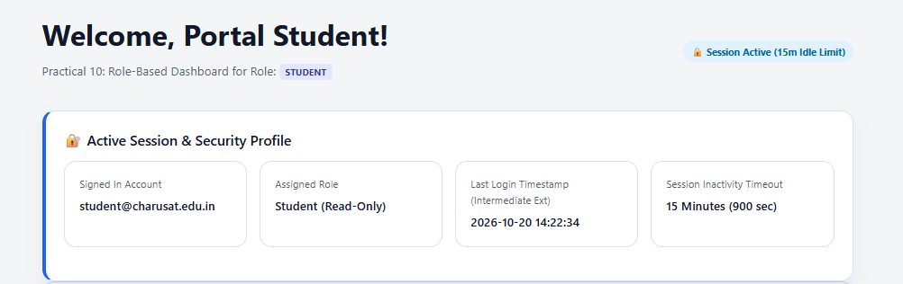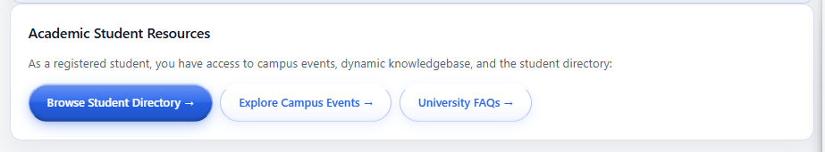

Password Mismatch error:
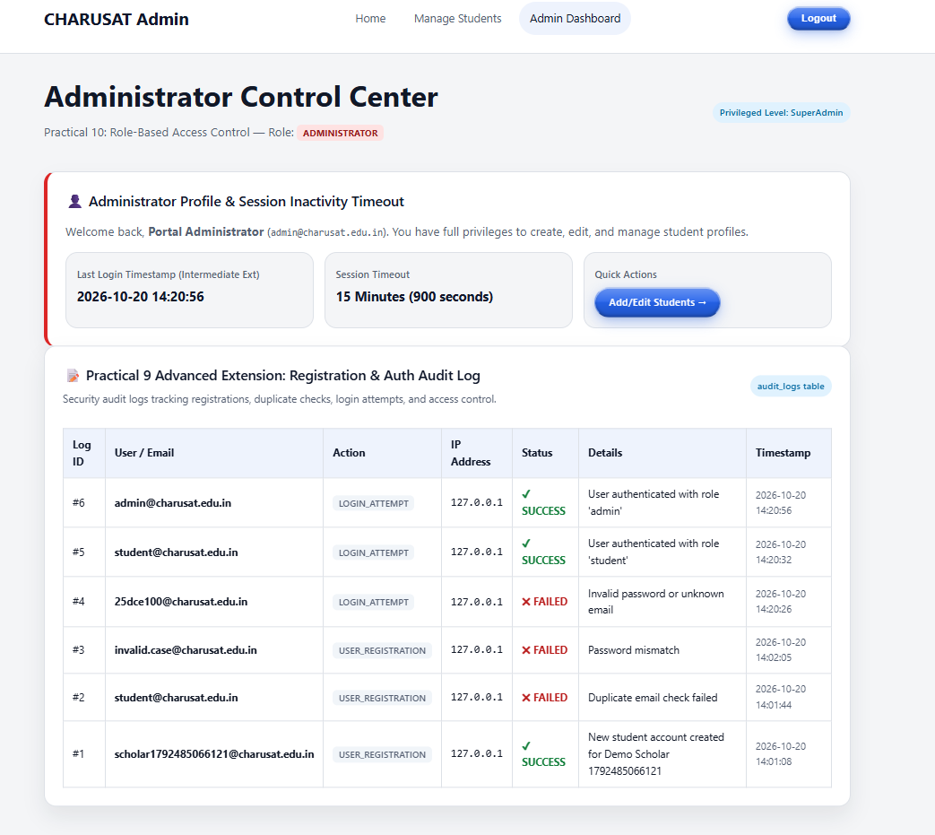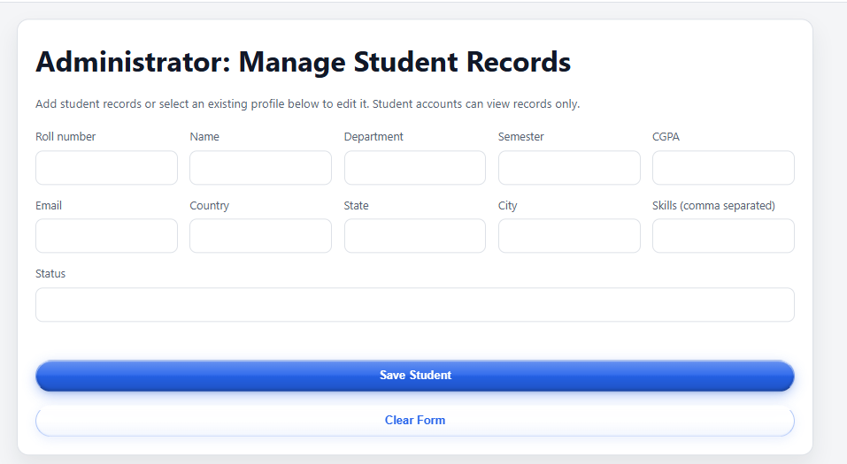
Wrong Login Details:
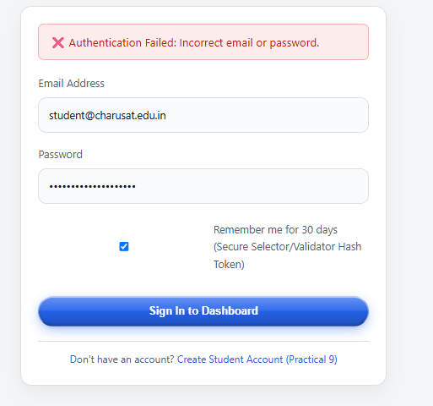

Repository Link :-
https://github.com/meet-3834/Student-Hub/tree/main/FINAL%20Submission

- Learning Outcomes:
I am able to implement secure user registration following basic web
security practices.

Faculty Remarks: (Keep this blank for faculty)

